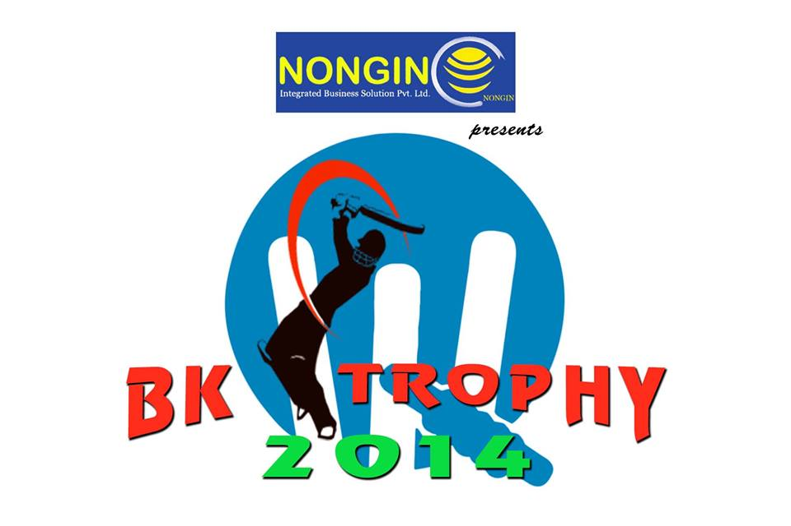

VENUE : IRILBUNG HIGH SCHOOL GROUND,IMPHAL EAST.
ORGANISED BY : YOUNG CRICKETERS, BAMON KAMPU, IMPHAL EAST.

Submit the completed Form @ :

MANAGEMENT COMMITTEE BK TROPHY 2014,
BAMON KAMPU , IMPHAL EAST, MANIPUR – 795001.
CONTACT NO. : 09862200195 [Folen] / 08730893504 [Sunil]
EMAIL : bktrophy@gmail.com
FACEBOOK : https://www.facebook.com/bktrophy2014

THE 5TH STATE LEVEL OPEN TENNIS BALL CRICKET TOURNAMENT

THE 5TH STATE LEVEL OPEN TENNIS BALL CRICKET TOURNAMENT

It gives us immense pleasure to invite your team to participate in
the forth coming Nongin presents BK Trophy 2014 the 5th State Level Tennis Ball
Open Cricket Tournament.

Like previous season, this season also we plan to conduct the above
tournament in their full glory and sportsman spirit.

The entry fee for the Tournament is ` 3,000/-
The Ball Fee per match for the Tournament is ` 350/-
The event is scheduled to be commenced by 5th of January 2014.
The fixture for the event would be drawn by 4th of January 2014.

Kindly confirm your participation by submitting the completely filed Admission Form
at our below office address on or before 31st December 2013.

Looking forward to your continued support in making BK Trophy 2014 The 5th Tennis Ball Cricket Tournament as successful as ever.

# For Online Downloaded Forms, ` 350/- will be charged at the time submission.

Best Regards

BK Trophy 2014
Management Committee

How to reach us :

MANAGEMENT COMMITTEE BK TROPHY 2014,
BAMON KAMPU , IMPHAL EAST, MANIPUR – 795001.
CONTACT NO. : 09862200195 [Folen] | 08730893504 [Sunil]
EMAIL : bktrophy@gmail.com
FACEBOOK : https://www.facebook.com/bktrophy2014

THE 5TH STATE LEVEL OPEN TENNIS BALL CRICKET TOURNAMENT
ORGANISED BY : YOUNG CRICKETERS, BAMON KAMPU, IMPHAL EAST.
.

ADMISSION FORM

TEAM PROFILE
Name of Team ( in block letters only)

Name of Team Captain

Contact Number
Email

Organisation / Club

Address

Name of Team Manager

Contact Number
Email

Address

Player Profile

Name
Affix a recent
Passport
Size colour
Photograph
Of the player
Here

Address

Signature of the Player
For Official Use Only
Player ID

Contact Number

Date of Birth
D | D | M | M | Y | Y | Y | Y | Blood Group

Name
Affix a recent
Passport
Size colour
Photograph
Of the player
Here

Address

Contact Number
For Official Use Only
Player ID

Date of Birth
D | D | M | M | Y | Y | Y | Y | Blood Group

Signature of the Player

Name
Affix a recent
Passport
Size colour
Photograph
Of the player
Here

Address

Signature of the Player
For Official Use Only
Player ID

Contact Number

Date of Birth
D | D | M | M | Y | Y | Y | Y | Blood Group

Name
Affix a recent
Passport
Size colour
Photograph
Of the player
Here

Address

Contact Number
For Official Use Only
Player ID

Date of Birth
D | D | M | M | Y | Y | Y | Y | Blood Group

Signature of the Player

Name
Affix a recent
Passport
Size colour
Photograph
Of the player
Here

Address

Signature of the Player
For Official Use Only
Player ID

Contact Number

Date of Birth
D | D | M | M | Y | Y | Y | Y | Blood Group

Name
Affix a recent
Passport
Size colour
Photograph
Of the player
Here

Address

Contact Number
For Official Use Only
Player ID

Date of Birth
D | D | M | M | Y | Y | Y | Y | Blood Group

Signature of the Player

Name
Affix a recent
Passport
Size colour
Photograph
Of the player
Here

Address

Signature of the Player
For Official Use Only
Player ID

Contact Number

Date of Birth
D | D | M | M | Y | Y | Y | Y | Blood Group

Name
Affix a recent
Passport
Size colour
Photograph
Of the player
Here

Address

Contact Number
For Official Use Only
Player ID

Date of Birth
D | D | M | M | Y | Y | Y | Y | Blood Group

Signature of the Player

Name
Affix a recent
Passport
Size colour
Photograph
Of the player
Here

Address

Signature of the Player
For Official Use Only
Player ID

Contact Number

Date of Birth
D | D | M | M | Y | Y | Y | Y | Blood Group

Name
Affix a recent
Passport
Size colour
Photograph
Of the player
Here

Address

Contact Number
For Official Use Only
Player ID

Date of Birth
D | D | M | M | Y | Y | Y | Y | Blood Group

Signature of the Player

Name
Affix a recent
Passport
Size colour
Photograph
Of the player
Here

Address

Signature of the Player
For Official Use Only
Player ID

Contact Number

Date of Birth
D | D | M | M | Y | Y | Y | Y | Blood Group

Name
Affix a recent
Passport
Size colour
Photograph
Of the player
Here

Address

Contact Number
For Official Use Only
Player ID

Date of Birth
D | D | M | M | Y | Y | Y | Y | Blood Group

Signature of the Player

Name
Affix a recent
Passport
Size colour
Photograph
Of the player
Here

Address

Signature of the Player
For Official Use Only
Player ID

Contact Number

Date of Birth
D | D | M | M | Y | Y | Y | Y | Blood Group

Name
Affix a recent
Passport
Size colour
Photograph
Of the player
Here

Address

Contact Number
For Official Use Only
Player ID

Date of Birth
D | D | M | M | Y | Y | Y | Y | Blood Group

Signature of the Player

Rules & Regulations

- The tournament shall be known as Nongin Presents BK Trophy 2014 the 5th State Level Open Tennis Ball Cricket Tournament.
- The tournament will be conducted on league cum knockout basis.
- If a team fails to report even after 30 minutes of the scheduled time, the opponents will be given a walk over.
- A player can participate in only one team. Each team should register all of its players with a copy of photo.
- Players of a team should be in uniform dress. No player will be allowed to play without shoes / playing kits. Players in improper uniform are not allowed to play.
- The venue of the match shall be the Irilbung High School Ground, Irilbung.
- In case a match is abandoned due to rain, bad light, or any other reasons, the winner will be the side with higher overall run rate.
- Disputes will be settled by the organizers in consultation with the umpires.
- Protests, if any, should be lodged within one hour after the completion of the match with a fee of Rs.200/-, refundable only if the protest is found to be valid.
- The organizers reserves the right to frame/change/modify any of the rules at any stage of the tournament, if found necessary.
- In case of Foot fault no ball, free hit will be given to the bats man in the ball following the no ball.
- In league round, winner will get 2 points while loser will not get any points. In case a match ends in a tie 1 point each will be awarded to both the teams.
- Net Run rate is calculated by using the Formula (Total Runs Scored/Total Overs played) - (Total Runs Given/Total Overs bowled)
- If more than one team is having the same no. of points pool winner will be decided on the basis of better Net run rate.
- Initial round will be played on league basis.
- All matches will consist of one innings per side, each innings being limited to a maximum of 20 overs.
- No bowler shall bowl more than 4 overs in an innings.
- At the instant of delivery, there may not be more than 5 fieldsmen.

Price Summary:

- Winner of BK Trophy 2014 : Cash award of ` 20000/- with BK Trophy.
- Runner of BK Trophy 2014 : Cash award of ` 10000/- with memento.
- Man of the Series of BK Trophy 2014 : Cash Award of ` 1000/- with memento.
- Man of the Match of BK Trophy 2014 : Cash Award of ` 500/- with memento.

# Man of Match will be awarded with a handsome amount of cash price in all matches.
# TC apply.

